Dawson Regional Planning Commission:

Terms of Reference 2018

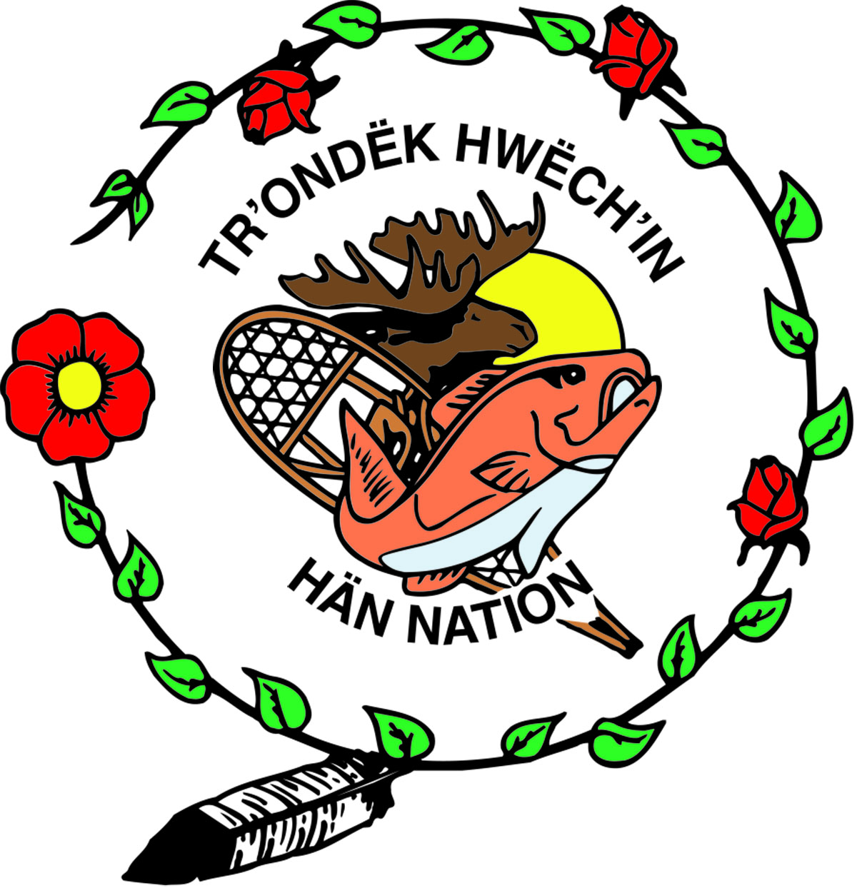

Contents:
Definitions
    - Introduction and Background
    - Purpose of the Terms of Reference
    - Mandate of the Commission
    - Purpose of the Plan
    - Boundary and Application of the Plan
    - Operating Procedures for the Commission
    - Administration of Commission Budget and Workplan
    - Relationships Between the Commission, Council, and the Parties
    - Participation and Engagement
    - Planning Products
    - Planning Process
    - Data, Background and Research Information
    - Plan Approval
    - Amending and Monitoring the Terms of Reference

Appendices:
- Mandate of the Yukon Land Use Planning Council
- Terms of Reference for Technical Working Group
- Terms of Reference for Senior Liaison Committee
- Protocols for Decision Making
- Detailed Timeline
- Map of the Dawson Region Planning Boundary

Definitions
Beyond this document, these definitions are to be used by the Dawson Regional Planning Commission (Commission), and in all the Commission’s publications.
Affected First Nation: A Yukon First Nation whose traditional territory is included within a Yukon land use planning region. The Affected First Nations of the Dawson Regional Planning process are: Tr’ondëk Hwëch’in, Vuntut Gwitchin First Nation, and the First Nation of Na-Cho Nyäk Dun.
Approval Parties: The Government of Yukon (YG) and the Tr’ondëk Hwëch’in (TH) who own and administer land within the Dawson planning region.
Draft Plan: The version of the plan that exists before the Recommended Plan. The Commission is responsible for public engagement/consultation on the Draft Plan.
Final Recommended Plan: The plan created after the Commission considers modifications proposed to the Recommended Plan by the Parties (sections 11.6.3.1 & 11.6.5.1 THFA). The Parties are responsible for Consulting on this version (sections 11.6.3.2 & 11.6.5.2 THFA). This version may not be required if the Recommended Plan is approved by the Parties.
Parties: Same definition as Approval Parties.
Recommended Plan: The version of the plan created after the Draft Plan (section 11.6.1 THFA). The Parties are responsible for Consulting on this version and may elect to approve it, reject it or propose modifications. (sections 11.6.2 & 11.6.4 THFA).
Senior Liaison Committee (SLC): This committee is the primary means of communication for overarching policy advice from the Parties and liaising with the Commission. The Terms of Reference for the SLC are outlined in Appendix C.
Technical Working Group (TWG): This committee is the primary means of facilitating communications regarding technical matters and existing policy matters among the Commission, the Council and the Parties. TWG members will also facilitate the provision of information from their respective governments to the Commission. The Terms of Reference for the TWG are outlined in Appendix B.
Transfer Payment Agreement: A funding agreement made between the Commission, the Yukon Land Use Planning Council (or, “the Council”), and the Yukon Government. Funding agreements enable the Commission financially in accordance with an approved budget and workplan.
Yukon Land Use Planning Council: S. 11.3.2 of the Tr’ondëk Hwëch’in Final Agreement establishes the Yukon Land Use Planning Council. It is responsible for making recommendations to Government and each affected Yukon First Nation on land use planning matters.

* For additional relevant definitions not provided above, see the Tr’ondëk Hwëch’in Final Agreement.

Introduction and Background
The Tr’ondëk Hwëch’in signed its Final Agreements with the Government of Canada and the Government of Yukon in 1998. In 2006, the Tr’ondëk Hwëch’in requested the establishment of a regional land use planning commission based on Chapter 11 of the THFA:
Government and any affected Yukon First Nation may agree to establish a Regional Land Use Planning Commission to develop a Regional Land Use Plan (11.4)
A Dawson Regional Planning Commission was established in 2011, but in 2014 the planning process was suspended by the Parties until the legal proceedings around the Peel Watershed planning process were resolved (First Nation of Nacho Nyäk Dun v. Yukon, 2017).
These Terms of Reference (TOR), developed with assistance from the Yukon Land Use Planning Council (Council) after consulting with the Parties, provide guidance for the completion of a regional land use plan based on a continuance of the planning process from its abeyance as of November 24 in 2014.
At the time of the abeyance, the Commission had started a draft land use plan, a report on the cumulative effects of future land use and had published foundational documents including an Interests and Issues Report (2011), a Resource Assessment Report (2013), and Plan Alternatives (2014).
With the resumption of the planning process, the Commission will be provided an updated Interests and Issues Report, an updated Resource Assessment Report, and a draft report on cumulative effects of potential future land use. Other documents produced by the previous Commission (draft land use plan, plan alternatives etc.) will be provided to the Commission for reference.

Purpose of the Terms of Reference
The Terms of Reference (TOR) provides direction to the Commission for preparing a regional land use plan for the Dawson Planning Region. The TOR describes the roles of the Parties, the Council, and the Commission, and outlines the products, timelines, available budget and processes expected during the Commission’s term. Roles, responsibilities and inter-relationships among the Parties and/or Council may be further defined in other agreements.
In the event of any inconsistency between the TOR and the Final Agreements of the Affected First Nations, those Agreements will prevail. If the Commission has questions about interpretations of the Final Agreements, it will direct those questions to the Senior Liaison Committee for resolution on behalf of the Parties to the Agreement (Chapter 11). This correspondence will be copied to the Council.

Mandate of the Commission
Working with the Parties, and through public participation, the Commission will develop a regional land use plan for Settlement Land and Non-Settlement Land that is consistent with, and achieves, the objectives of Chapter 11 of the Tr’ondëk Hwëch’in Final Agreement.
Unless otherwise agreed upon by the Parties through annual work plans, the Commission, within the time frame provided in Section 11, will forward a Recommended Plan by March 31, 2021 and, if required, a Final Recommended Plan, by September 2021, to the Parties for their consideration.

Purpose of the Plan
The purpose of a regional land use plan is to provide guidance for future land use and an indication of the desired future state of the region. This guidance may include the identification of varying degrees or types of land use in specific areas of the planning region, and should provide land use decision makers, assessors and land users with guidance and direction on the use of land, water and other renewable and non-renewable resources. By bringing clarity to the appropriate uses and levels of use of the land, a regional plan helps create certainty for land users and assists in avoiding future land use conflicts.
The Commission should consider potential future land uses and their implications. The time horizon for these considerations should be no less than 20 years.
The plan will be reviewed periodically to accommodate new and changing land uses, interests and information.

Boundary and Application of the Plan
  - The boundary of the Dawson Planning Region is shown in Appendix F. In general, the planning area extends:
- north to the contiguous boundary agreed to by the Tr’ondëk Hwëch’in and Vuntut Gwitchin First Nation to resolve the overlap between their traditional territories as modified to exclude the entire area previously designated as Land Management Unit 7 by the Dawson Planning Commission in their January 2014 document, Plan Alternative Package;
- southeast to northwestern most extent of the Selkirk First Nations Traditional Territory (see Selkirk Nation Final Agreement);
- southwest to the northern boundary of the Kluane First Nation Traditional Territories (see Kluane Final Agreement);
- east to the boundaries associated with the Peel Watershed Planning Region and the Overlap Agreement signed between the First Nation of Na-cho Nyäk Dun and the Tr’ondëk Hwëch’in; and
- west to Yukon/Alaska border.
  - As per 11.2.1.1, the Regional Land Use Plan will apply to both Settlement Land and Non-Settlement Land throughout the region with the exception of lands referred to in 8.3.
  - As per 11.2.2, the Regional Land Use Plan will not apply to:
a) land within the City of Dawson and areas subject to subdivision planning or local area planning outside of a municipal boundary (e.g. West Dawson, Sunnydale);
b) the Klondike National Historic Sites; and
c) Tombstone Territorial Park.
  - Existing management plans in the region shall be considered in the development of the regional land use plan.

Operating Procedures for the Commission
  - Based on 11.4.2 of the Yukon First Nation Final Agreements, the Commission will consist of six (6) members:
- two (2) members nominated by the Tr’ondëk Hwëch’in;
- two (2) members nominated by the Government of Yukon; and
- two (2) members nominated based on regional demographics: one (1) by the Government of Yukon and one (1) by the Tr’ondëk Hwëch’in.
  - The majority of nominees shall be Yukon residents with a long-term familiarity with the region and shall be appointed by the responsible Minister.
  - The appointment of the Commission members will occur as defined in Chapters 2 & 11 of the Tr’ondëk Hwëch’in Final Agreement.
  - The Commission will adhere to the provisions of section 2.12.2 of the Tr’ondëk Hwëch’in Final Agreement.
  - The Commission will utilize the 2018 Policy and Procedures handbook drafted by the Yukon Land Use Planning Council and reviewed by the Parties.
  - Commission meetings and business will be carried out in an open and accountable manner. Notwithstanding the above, the Commission may close a meeting to the public during a discussion on a matter that relates to the following:
      - commercial information which, if disclosed, would likely be prejudicial to the planning process or parties involved;
      - information received in confidence which, if disclosed, would likely be prejudicial to the planning process or parties involved;
      - personal information, including personnel information;
      - the salary and benefits and any performance appraisal of an employee;
      - a matter still under consideration and on which the commission has not yet publicly announced a decision and about which discussion in public would likely prejudice the Commission’s ability to carry out its activities or negotiations;
      - the conduct of existing or anticipated legal proceedings; and
      - the conduct of an investigation under, or enforcement of, an Act.2
  - Honoraria rates will be consistent with the rates identified for the Yukon Government boards and committees.
  - Remuneration rates for food, accommodations and other costs associated with travel and meetings may not exceed the rates for such costs used by the Yukon Government in respect of its employees and as may be amended from time to time.
  - Quorum for Commission meetings will be no less than four. Decisions of the Commission will be made by consensus whenever possible and be guided by the “Protocols for Decision Making” (Appendix D).
  - If a Commission member has been absent without reasonable cause for two (2) consecutive Commission meetings, this absence may be considered grounds for requesting the resignation of the member.
  - In the event that a Commission member resigns, the Commission Chair will confirm the resignation with the Minister in writing.
  - Commission members will exhibit respect towards one another and all involved people for the duration of their service to the Commission. The Commission may choose to develop a Code of Conduct.
  - Whenever possible, the work of the Commission will take place within the planning region.

Administration of Commission Budget and Workplan
  - The overall 24-month budget is $490,000 for the fiscal years 2019/2020 and 2020/2021. If required, a budget for 2021/2022 will be determined. The Commission will operate on a fiscal calendar.
  - The Council will provide funds for the fiscal year 2018/2019 and into part of 2019/2020.
  - The Commission, after consultation with the Parties, will prepare a budget/workplan each fiscal year for the preparation of the land use plan, and for carrying out its functions under Chapter 11 of the Tr’ondëk Hwëch’in Final Agreement, and will submit that budget/workplan to the Council for review. The Commission may request assistance from the Council in preparing the budget/workplan.
  - This proposed budget/workplan will be submitted to the Council by the dates identified in the funding agreements and will address funding and activities for the following fiscal year. The budget & workplan will be consistent with this Terms of Reference and the Tr’ondëk Hwëch’in Final Agreement.
  - The Council, after consultation with the Commission, will recommend the budget/workplan to the Parties. On approval of the budget by Yukon Government and the workplan by the Parties, the budget and workplan will be attached to the funding agreement and signed at the appropriate approval level. Joint meetings may be organized to streamline the workplan/budget production and approval process.
  - The Commission will make best efforts to adhere to the approved workplan, timelines and budget. The Council and the Parties will take action to support the Commission's effort to adhere to the workplan and budget.

Relationships between the Commission, the Council and the Parties.
  - The Commission will use the Technical Working Group (TWG) as the primary means of obtaining information on technical matters. TWG members will also facilitate the provision of information from their respective governments to the Commission. The Terms of Reference for the TWG are outlined in Appendix B.
  - The Commission will use the Senior Liaison Committee (SLC) as the primary means of clarifying policy advice. The Terms of Reference for the SLC are outlined in Appendix C.
  - The Parties, via the SLC or TWG, will have opportunities to make presentations at Commission meetings, as needed.
  - The Commission will ensure the Council and the Parties are involved throughout the planning process. The Commission should strive for consensus with the Parties, whenever possible, on key plan directions.
  - Periodic reviews of draft products by the Council and the Parties are intended to assist the Commission in fulfilling its mandate and are to be completed in a timely manner so as to not delay the Commission’s progress.
  - The Commission will keep the Council and the Parties apprised of its activities and progress throughout the planning process. This will be accomplished by distribution of meeting agendas and meeting minutes, submission of progress reports relative to the timelines identified in the Terms of Reference, submission of annual reports relative to the timelines identified in the workplan, and by any other means the Parties and/or the Council may request.
  - The Council secretariat will facilitate the provision of human resources for the completion of the plan based upon a Memorandum of Understanding (MOU) between the Commission and the Council. The MOU will define financial arrangements, roles, responsibilities and reporting relationships. The MOU will be shared with the Parties, and will not conflict with this Terms of Reference.
  - In the event that disagreements arise between Commission members, or between the Commission, the Council and the Technical Working Group that cannot be resolved, the SLC will initiate a dispute resolution process.

Participation and Engagement
As per 11.2.1.8 of the Tr’ondëk Hwëch’in Final Agreement, public participation is a requirement of the planning process. Throughout the planning process the Commission will as follows:
  - Utilize the knowledge and traditional experience of Yukon Indian People, and the knowledge and experience of other residents of the planning region (11.4.5.5).
  - Ensure adequate opportunity for public participation.
  - Seek views of adjacent jurisdictions where trans-boundary issues and/or resources are identified.
  - Recognize its responsibility to participate in the YESAB assessment of proposed projects occurring in the planning region while land use planning is in progress (12.17.2).
  - Seek and consider the views of land and resource management departments and agencies (e.g. Dawson District Renewable Resources Council, YESAB, Porcupine Caribou Management Board, and Forty Mile Caribou Harvest Management Coalition) that are relevant in the planning region and in adjacent areas that affect the planning region.
  - Engage with the communities of Dawson, Old Crow, Mayo and Whitehorse.
  - Strive for open and representative public engagement processes using transparent engagement strategies.

Planning Products
  - The Commission will produce a number of products to fulfill its planning and public engagement responsibilities:
- Vision Statement and Planning Principles: Developed and approved by the previous Commission, this Commission is encouraged to review, modify if required, and adopt.
- Issues and Interest Report: Developed and approved by the previous Commission and recently updated by the Parties and YLUPC; the Commission is encouraged to review, modify if required, and adopt.
- Resource Assessment Report: Developed and approved by the previous Commission and recently updated by the Parties and YLUPC; the Commission is encouraged to review, modify if required, and adopt.
- Exploring the Cumulative Effects of Future Land Use in the Dawson Planning Region: This draft report will be reviewed by the Parties prior to being reviewed and endorsed by the Commission.
- Draft Plan: this is a complete regional land use plan that is comprised of concepts developed during internal discussions and input from the Parties and the public. The Commission is responsible for public engagement/consultation.
- A report on the outcome of consultation on the Draft Plan: This should summarize the Parties’ and public’s input on the Draft Plan.
- Recommended Plan: this is a complete regional land use plan that represents the Commission’s recommendation for a Dawson Regional Land Use Plan, based upon the Commission’s vision and values, objectives of Chapter 11 established under the THFA and upon feedback on the Draft Plan from the public and the Parties. The Parties are responsible for community consultation on the Recommended Plan.
- If needed, a Final Recommended Plan. As per 11.6.3.1 and 11.6.5.1, the Regional Land Use Planning Commission shall reconsider the plan and make a final recommendation for a regional land use plan to {the Parties}. This final recommendation for a land use plan would be in response to proposed modifications and written reasons provided by Government and/or the affected Yukon First Nation (11.6.3 and 11.6.5). The Parties are responsible for community consultation on the Final Recommended Plan.
- Plain Language Summary Documents of the Draft, Recommended and if needed the Final Recommended Plan.

Planning Process
  - In preparing the plan, the Commission will follow the steps as outlined below.
 | 2018/19 |  | 2019/20 |  |  |  | 2020/21 |  |  |  | 2021/22
 | Q3 | Q4 | Q1 | Q2 | Q3 | Q4 | Q1 | Q2 | Q3 | Q4 | Q1 | Q2
COMMISSION STARTUP
PREPARE DRAFT PLAN
Issues and Interests Report
Resource Assessment Report
Goals Statement(s)/Plan direction
Develop draft plan
Public review
PREPARE RECOMMENDED PLAN
PREPARE FINAL RECOMMENDED PLAN (if Recommended Plan not approved)
Plan revision, Final Recommended Plan delivered

A detailed timeline chart is attached in Appendix E. The planning process will include the following stages.
Commission Start-up Period:
- The Commission will convene its first meeting as soon as practicable and within six weeks of being established. The initial meeting of the Commission should be convened by the members with organizational assistance from the Council.
- The Council will provide an extensive start-up training program, and subsequent training modules as needed for the remainder of the planning process. The Commission orientation and training will be consistent with the training outlined in the First Nation Final Agreement Implementation Plan, Annex B, Part 2; and will include the Tr’ondëk Hwëch’in 101 course.
- The Commission will receive logistical and planning support from the Council secretariat. The recruitment process for Commission staff should be consistent with the norms of a public recruitment process.
- The Commission will review the Vision Statement and Planning Principles approved by the previous Commission, and will modify and ratify as needed.
- The Commission will review the Issues and Interest Report (revised 2018) which summarizes the issues and interests of the Parties in the region, and determine if subsequent research and analyses is required, or whether it is acceptable as is.
- The Commission will review the Resource Assessment Report (revised 2018) examining land, water and renewable and non-renewable resource uses and their interactions, and determine if subsequent research and analysis and/or maps are required, or whether it is acceptable as is.
Products: Updated and approved Vision Statement and Planning Principles, Issues and Interests Report, Cumulative Effects Report and Resource Assessment Report.
Plan Development Stage:
The Dawson Regional Land Use Plan will address the requirements outlined in Chapter 11 of the Tr’ondëk Hwëch’in Final Agreement and provide:
- an introduction to the planning region and a description of the planning process used in the production of the regional land use plan;
- plan goals and objectives;
- a regional land designation system throughout the planning region;
- regional management direction including specific recommendations for various land use sectors;
- direction on a Dempster Highway sub-regional plan consistent with other planning regions; and
- mechanisms and triggers for plan variance, amendments and reviews.
The Plan may also include recommendations for the identification of priority areas for sub-regional and local area development plans, and recommendations for implementation planning.
Products: Draft Plan, a report on the consultation on the Draft Plan, Recommended Plan, Final Recommended Plan (if necessary), Methods Reports (optional).
Other administrative documents: The Commission, with the assistance of the Council, will produce and submit other administrative documents to the Parties, including draft workplans and draft budgets, activity reports, and year-end reports as detailed in its funding agreement. They may also participate in hiring processes, if needed.

Data, Background and Research Information
The Commission will use the best available information for the production of the plans. The Parties will provide all relevant and available information and data to the Commission at the request of the Commission, except information considered confidential or compromising. In accordance with annual workplans and budgets, the Commission may also undertake its own studies, data collection and analysis where information gaps are identified. Information requests from the Commission will be made through the Technical Working Group. Parties will make their best effort to provide information to the Commission in a timely manner. The Parties recognize that delays in providing information to the Commission will result in delays in the Commission’s workplan. Data and other information will be housed by the Council to help ensure consistent information management.

Plan Approval
The Approval Parties for the plan are the Yukon Government and the Tr’ondëk Hwëch’in. The process for approving the recommended regional land use plans is provided in 11.6.0 of the Tr’ondëk Hwëch’in Final Agreement.

Amending and Monitoring the Terms of Reference
This Terms of Reference may be amended by agreement in writing between the Government of Yukon and Tr’ondëk Hwëch’in. The Parties, as well as the Commission and the Council, will monitor compliance with the Terms of Reference.

Parties Signature Page

Signed at Dawson City, Yukon this ___ day of __________2018
Tr’ondëk Hwëch’in

_____________________________________
Chief,
Roberta Joseph

Signed at Whitehorse, Yukon this ___ day of __________2018
Government of Yukon Government of Yukon

____________________________________ _________________________________
Minister of Energy, Mines and Resources, Minister of Environment,
Ranj Pillai Pauline Frost

Commission Members Sign Off

In signing this Terms of Reference, Commission members acknowledge that they have read, understood, and agreed to the terms of the Dawson regional land use planning process, and their associated roles, relationships, and responsibilities.

Dawson Regional Planning Commission: Witness:

_________________________ ________________________________
DRPC Member

___________________________ ________________________________
DRPC Member

___________________________ ________________________________
DRPC Member

___________________________ ________________________________
DRPC Member

___________________________ ________________________________
DRPC Member

___________________________ ________________________________
DRPC Member

Appendix A

Mandate of Yukon Land Use Planning Council
Mandate
The mandate of the Yukon is to make recommendations to Government and each affected Yukon First Nation regarding:
- Land use planning, including policies, goals and priorities;
- Identification of planning regions and priorities for regional land use plans;
- The general terms of reference for each Regional Land Use Planning Commission;
- The boundary of each planning region; and
- Such other matters as Government and the affected Yukon First Nation agree.
The Council reviews and recommends the workplan and budgets of regional planning commissions to Yukon.
Composition
The Yukon Land Use Planning Council is made up of three people, one nominated by CYFN, one nominated by Yukon and one nominated by Canada.
Operating Procedures
The Council operates under the policies defined in Yukon Land Use Planning Council Policy and Procedures
Assistance to be provided to the Commission
- Provide the orientation of the Commission and ongoing training;
- Provide a template for the Commission’s policies and procedures;
- Review and recommend the annual workplan/budget for the Commission;
- Enter into a financial agreement with the Commission for its funding (jointly with Yukon);
- Provide the human resources (staff) for the production of the land use plan, including financial administration services. This will be identified in a Memorandum of Understanding between the Commission and the Council;
- Participate on the Technical Working Group (TWG) and Senior Liaison Committee (when asked to do so).

Appendix B
Terms of Reference: Technical Working Group
Mandate
The mandate of the Technical Working Group (TWG) is to provide coordinated technical information and support to the Dawson Regional Planning Commission (the Commission). This includes:
- Acting as the primary point of contact between the Commission and governments on technical matters related to the preparation of the land use plan;
- Providing technical input and advice to the Commission regarding relevant Yukon Government issues, policies, programs and initiatives for consideration in the preparation of the plan;
- Providing technical input and advice to the Commission regarding relevant Tr’ondëk Hwëch’in issues, policies, programs and initiatives for consideration in the preparation of the plan;
- Coordinating delivery of information to and from the Parties;
- Making determinations on the ability for the Parties to respond to information requests from the Commission;
- Seeking direction from the SLC on key policy items.
In the event that anything in this Terms of Reference conflicts with the Final Agreements of the Affected First Nations, those Agreements will prevail.

Composition
The TWG will be comprised of the Senior Planner for the Commission, one representative from the Yukon Land Use Planning Council, one representative from Yukon Energy, Mines and Resources, one representative from Yukon Environment, and up to two representatives from the Tr’ondëk Hwëch’in government. Other representatives from the Parties may participate as required. Federal representatives with interests and mandates in the planning region may also be invited to participate.

Operating Procedures:
- The TWG will be chaired by the Senior Planner for the Commission, or in the absence of the Senior Planner, one of the other participants;
- Meetings will occur at the request of the Parties or the Commission;
- The TWG will make the best efforts to operate on the basis of consensus;
- The TWG will attend all Commission meetings as a resource and to facilitate communication between the Commission and the Parties;
- The secretariat services for the TWG will rotate amongst the members;
- Each member organization will be responsible for covering its own costs for participating on the TWG;
- TWG members will represent the technical and policy interests of their respective governments;
- Members will be keep their respective governments informed of the key issues and items discussed during TWG business;
- The TWG will remain in effect until the Parties agree otherwise;
The Parties may amend Appendix B containing the TWG Terms of Reference by agreement in writing.

Appendix C

Terms of Reference: Senior Liaison Committee
Mandate
The mandate of the Senior Liaison Committee (SLC) is to provide coordinated, senior level, governmental input, advice and support to Dawson Regional Planning Commission as may be required to address issues in the preparation of the plan. This includes:
- Acting as the primary conduit between the Commission and governments on political matters related to the preparation of the land use plan;
- Providing input and advice to the Commission regarding relevant government issues, policies, programs and initiatives for consideration in the preparation of the plan;
- Responding to any questions the Commission may have on policy matters;
- Providing overarching policy advice;
- Assisting the Commission to meets its obligations and timelines under its Terms of Reference and funding agreements.
The SLC will make best efforts to operate on a consensus basis regarding the advice it provides to the Commission.
In the event that anything in this TOR conflicts with the Final Agreements of the Affected First Nations, those Agreements will prevail.
Composition
The SLC will be comprised of one senior representative of Yukon Energy, Mines and Resources, one senior representative of Yukon Environment and one senior representative of the Tr’ondëk Hwëch’in government. SLC members will be formally designated by each Party. The Chair and Senior Planner of the Dawson Regional Planning Commission will be invited to participate in SLC meetings. Federal representatives with interest and mandates in the planning region may also be invited to participate, as may representatives of the Yukon Land Use Planning Council, affected First Nations, the Commission, and the Technical Working Group.
Operating Procedures
The SLC will meet monthly or as required, to receive updates on planning progress, provide input and advice and work towards governmental consensus on planning issues, including but not limited to:
- Development of the Commission’s budget/workplan;
- Planning Region Issues and Interests;
- Resource Assessments and Reports;
- Planning products;
- Reponses to the Recommended Plan, and if necessary;
- Responses to the Final Recommended Plan.
Each Party or invited participant will be responsible for covering its own costs for participating on the SLC.
The Yukon government will provide secretariat services for the SLC.
Meetings will be chaired by each member on a rotating basis.
SLC members will represent the broad interests of their respective governments and will be responsible for keeping their governments informed of the key issues encountered during the planning process.
Amendment
The Parties may amend Appendix C containing the SLC Terms of Reference by agreement in writing.

Appendix D
Protocols for Decision Making
- The Commission, to the extent practicable, will make decisions by consensus. Consensus-based decision-making is a process of arriving at a decision that reflects and relies upon satisfying the interests, values and concerns of the whole group responsible for making the decision.
- Within a consensus-based decision-making environment, Commission members have the responsibility to:
- Be committed to relying upon the agreed upon consensus process to construct the decision;
- Ensure that all members are adequately informed and knowledgeable of the issues surrounding the decision;
- Ensure all members’ interests, values and concerns are openly articulated and understood;
- Ensure all members’ interests, values and concerns are addressed and reflected in the decision;
- In order to create and maintain a consensus-based decision-making environment, the following techniques should be used:
- All members need to invite, welcome and respect the interests, values and concerns of each Commission member;
- The Commission must ensure, through flexible arrangements and other measures that all decision-makers participate in all phases of constructing the decision.

- Examples of consensus-based techniques include:
- Exploring many options and solutions;
- Determining the underlying issues and interests;
- Providing new or additional information to illuminate interests, values or concerns;
- Separating personal conflict from decision-making;
- Assessing level of agreement among members;
- Avoiding taking hard and fast positions;
- Deciding when to postpone a decision for future discussion;
- Defer construction of a decision until interests, values and concerns are addressed;
- Re-configuring the issue or question;
- Seeking alternative solutions to a problem;
- Making incremental decisions rather than addressing large questions all at once; and
- Invite and encourage independent advisors, mediators and experts to facilitate understanding, or to assist in the construction of a decision.
- For clarity, the following should be noted:
- Decisions made when all members are not informed and educated on a matter is not consensus;
- Decisions made by individuals or by less than quorum is not consensus;
- A decision made by a simple vote without seeking and exhausting more acceptable alternatives is not consensus; and
- Voting is a fundamentally different decision-making process than making decisions by consensus. Voting is not consistent with a consensus-based decision-making process.
- When internal efforts have not provided for a decision to be made by consensus, a Commission should invite, and welcome, other resources to enable a consensus to be reached. These other resources may include:
- Employing a facilitator from outside the Commission;
- Seeking guidance about an issue through public consultation; and
- Seeking guidance from the Parties, Council or a knowledge holder(s).
7. Decisions and resolutions must be recorded in the minutes with a clear indication that consensus has been reached. In the event that other decision-making measures are used, such as majority voting, minutes should indicate that consensus was attempted, failed and that a vote occurred. Minutes should also record where conditions or limitations have been placed on an action or decision.

Appendix E
Detailed Timeline

Appendix F
Map of the Dawson Planning Region
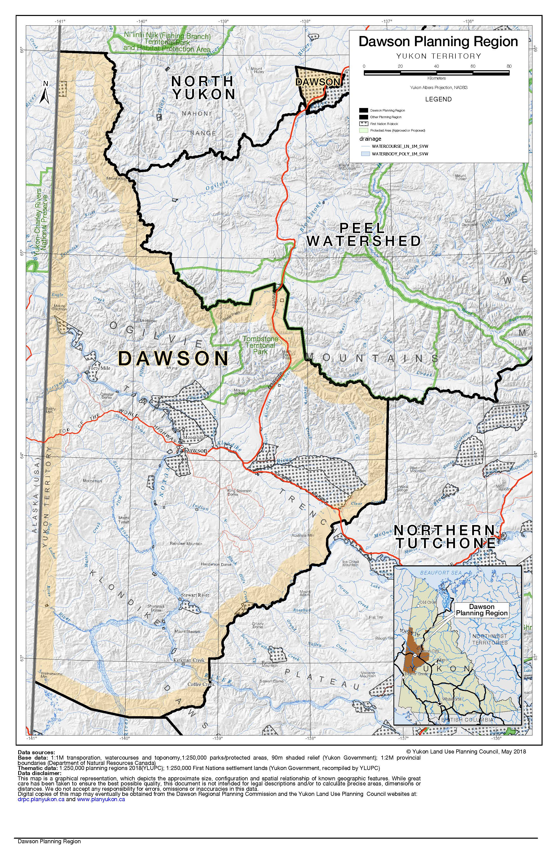

2 Language for this section was borrowed from the Yukon Municipal Act section 213

