the Status and Directions of DRPC Products
By: Sam Skinner
On: 2017-09-13
This briefing note details the content, direction, and shortcoming or requirements of DRPC products that were completed or in progress at the time of abeyance in December 2014.

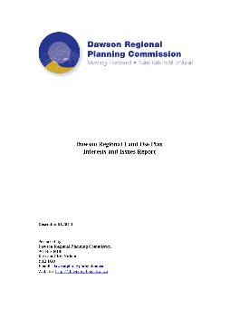
Issues and Interests Report
The Commission’s record of the input (both written and from community meetings) from the Yukon Government, Tr’ondëk Hwëch’in Government and interested public stakeholders. It identifies 4 themes: 1) the cumulative effects of mining and exploration; 2) habitat conservation; 3) how a plan can achieve a “workable balance”; and, 4) land use conflict within the Yukon River Corridor.
Status: Completed December 2011
Shortcomings/Requirements: New issues that have arisen since 2011 will need to be identified (e.g., Indian River Wetlands).

Vision and Goals Statement
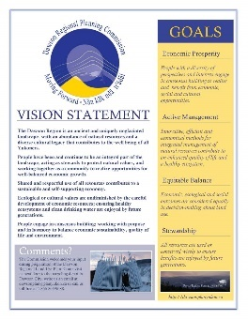
Five plain-language vision statements broadly describe the desired future state of the region. These were published with four Planning Goals (or Principles on the website) that describe a mix of how the plan is to be developed, outcomes of the plan and approaches to be used by the plan.
Status: Completed September 2013
Shortcomings/Requirements: The new Commission and/or the Parties may not agree with these statements. The Parties may wish to provide planning principles in the new Commission’s ToR.

Resource Assessment Report
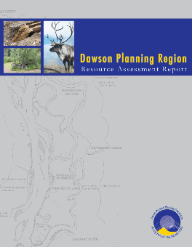
This comprehensive report attempts to document: the natural, human and economic resources in the region; the historical, current and potential future land uses and patterns; and, potential current and future land use issues.
Status: Completed October 2013. A summary was produced late 2014, but not published.
Shortcomings/Requirements: New information and developments that have arisen since 2011 will need to be identified (e.g., Indian River Wetlands, White Gold area projects and access, Tr’ondëk-Klondike UNESCO World Heritage Site nomination). The report does not forecast the location and extent of potential land use issues.

Plan Alternatives
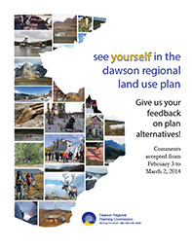
Leading up to the Alternatives document, the Commission and staff invested much time and effort considering decision-making processes, and finally landed on Structured Decision Making (or SDM). SDM requires the development of alternative options and a rigorous evaluation of them that clarifies trade-offs among the alternatives. Ironically, the deliberations on the process did not leave sufficient time to develop and analyse the alternatives in the rigorous and defensible way of SDM.
The Alternatives presented sketches of 5 alternative land use plans, all based on the same Land Management Units (LMUs) and Land Designation System (LDS). The LMUs were based primarily on the landscape units of the Dawson Forest Resources Management Plan (2013), watersheds and the Yukon River Corridor. The LDS used designations from the North Yukon Regional Land Use Plan (Integrated Management Areas (IMAs) Zones II-IV (though not possibly without cumulative effects indicators), Protected Areas), and introduced new ones: Yukon River Corridor (subject to sub-regional planning), Tradition Economy Area (interim withdrawal of new sub-surface rights to promote renewable resource development), and Conservation Area (legally designated “soft” protected area that would allow access through it to adjacent IMAs).
Status: Completed February 2014
Shortcomings/Requirements: Despite some shortcomings, the Alternatives served to get feedback on an LMU scheme the and some new land designations, as well as their distribution on the landscape.

What We Heard
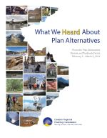
The WWH report described the consultation effort of the Alternatives, and went on to compile and analyse the feedback from it. The feedback was grouped into 4 themes, each with a discussion and examples quotes that were often contradictory. The themes were: 1) Provide more clarity on zones; 2) the Commission needs to fully consider the existing regulatory regime and its effectiveness; 3) Knowledge gaps and issues with data and modeling need to be addressed; 4) Use management tools that will be effective and implementable, and whose economic impacts have been fully considered. The WWH report also described the next steps, including the general contents of the Draft Plan.
Status: Completed January 2015 (after Commission approval via email)
Shortcomings/Requirements: None. A more succinct analysis may help focus renewed planning.

Cumulative Effects Report (DRAFT)
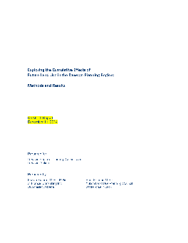
This report, written by S. Skinner (YLUPC) and S. Francis (consultant), reports on the how the disturbance (area & length of roads/trails) resulting from 20 years of continued development in 4 sectors (placer, quartz mining, oil & gas and forestry) under 2 scenarios (low and high activity) may increase. Based on detailed discussions with industry experts, models showed the relative increase in disturbance for each LMU. The report discusses implications of these forecasts on planning, with a focus on cumulative effects indicators. It also generally discusses potential effects on other values.
Status: Not approved or published. Advanced draft presented to Commission December 2014, but the Commission felt they and others did not have enough time to review it. The Commission wanted it shelved for the Commission to approve when it restarts.
Shortcomings/Requirements: The analysis is based on somewhat dated information, though general trends are likely still relevant. A rigorous analysis of forecasted disturbances on other values (e.g., wetlands) could be informative.

Draft Plan
A significant amount of the Draft Plan’s introductory and descriptive sections was completed with by S. Francis (contractor) and S. Skinner (YLUPC) with assistance of the TWG. LMUs and a simplified designation system were also developed, but not yet discussed sufficiently by the Commission. This system borrowed designations from the North Yukon RLUP for the northern portion of the Dawson Region. The rest of the region would not initially use cumulative effects indicators, but would provide directions for each LMU. Key directions included sub-regional planning for the Yukon River Corridor (with interim measures) and using the Territorial Lands Act to regulate all access in some LMUs (vs Quartz Act).
Status: Incomplete. Drafts of 5 of 6 chapters reached various levels of completion.
Shortcomings/Requirements: Numerous planning decisions and extensive writing are still required. The LMUs may not adequately address local concerns (e.g., small habitat features) and many don’t reflect potential land use issues, but were incidental results of overlaying the Yukon River Corridor over the landscape units.

Websites
The Commission asked the YLUPC to maintain their website, but not to add any content while it is in abeyance. Similarly, YLUPC’s website has no new information on the Dawson Commission.
Status: Software is up-to-date and maintained by YLUPC. No new content since early 2015.
Shortcomings/Requirements: New articles describing DRPC restart efforts should be posted on the YLUPC’s website.

